Head of Department,
Chest Diseases Hospital Dalgate,
Srinagar (J&K).
No: KGP/Estt/2026/98-99 Dated:11-04-2026
Subject: Request for Permission to Collect Anonymised Chest X-ray Datasets for Academic Project – Reg.
Sir,
This is with reference to the request submitted by the following final semester students of Diploma in Computer Engineering of this institution:
- Arib Shujaat
- Tanzeel Fatima
- Hafeel Bakshshi
- Mantasha Imtiyaz
The above students are undertaking their major project titled “Pneumonia Detection using Deep Learning” under the supervision of Dr. Aejaz Farooq.
For the successful implementation of the said academic project, the students require anonymized chest X-ray images (normal and pneumonia cases) for training and testing of the deep learning model.
We, therefore, kindly request you to grant permission to the aforementioned students to collect the required fully anonymized chest X-ray datasets from your esteemed hospital. The data collected shall be used strictly for academic purposes related to this project and shall not be shared with any third party.
Dr. Aejaz Farooq, Demonstrator, Computer Engineering, has been directed by this office to provide necessary guidance and supervision to the students regarding the proper collection, handling, and ethical use of the datasets. The students have been advised to follow all rules and procedures. Your kind cooperation and support in this academic endeavour will be highly appreciated and will greatly help our students in gaining practical exposure to real-world medical imaging and deep learning applications.

Yours Faithfully
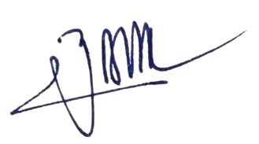

Principal
Kashmir Government Polytechnic College
Srinagar
Copy to the:
1. Dr. Aejaz Farooq, Demonstrator, Computer Engineering for information and necessary action.
2. Training and Placement Officer, KGP Srinagar for information.

